**Will sea turtles survive climate change?**

One part of the problem is that sea turtles have temperature-dependent sex determination (TSD). This means that, unlike us, their sex (whether they’re male or female) is determined by the environment instead of their DNA, like for humans. Specifically, warmer nests produce more female hatchlings and cooler nests produce more male hatchlings. Because of global climate change, nesting beaches are getting warmer and warmer, so they’re producing more and more female hatchlings. At what point are there not enough males to keep the population from going extinct?

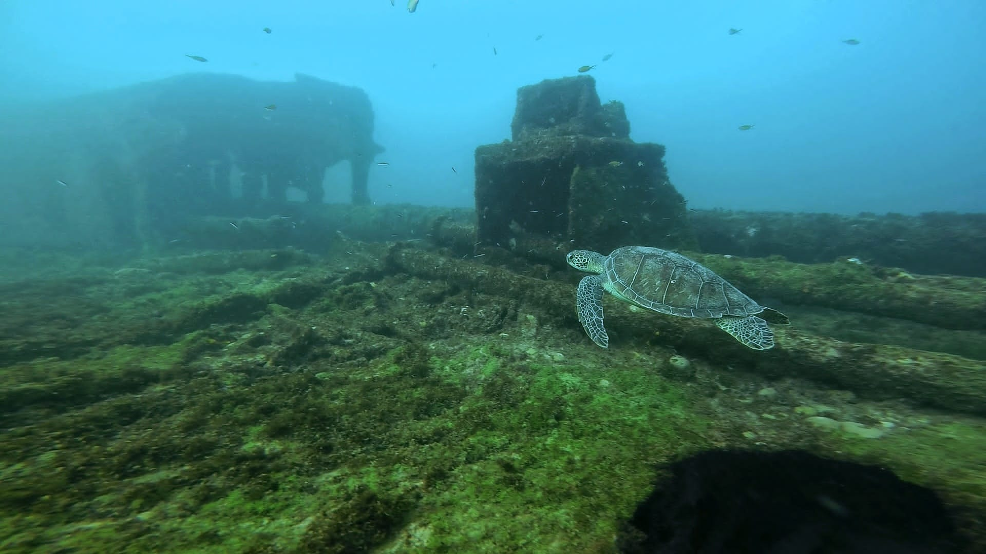

**P1. Juvenile green turtle swimming around Porto port in Fernando de Noronha, caught by Dr. Blair Bentley on his GoPro during a recreational SCUBA dive.**

A second part of the problem is that we don’t know a whole heck of a lot about male sea turtles. Females come up onto land to nest, so a lot of research focuses on them because they’re easier to find and keep track of. Males stay in the water, so they’re harder to find, get to, and study. Therefore, we don’t know a whole lot about male behavior. How often do they mate? How many females can and do they mate with? How far will they travel to mate over their lifetimes?

To answer some of these questions (and a whole bunch more), we’re partnering with other universities and Projeto TAMAR to study a population of green sea turtles that nests in Fernando de Noronha, Brazil. This population is perfect for us to study because not only do we have access to females and their nests, but also to the breeding grounds with males just off the coast. Dr. Mariana Fuentes leads the Marine Turtle Research Ecology and Conservation Group at Florida State University. Armando Santos is her PhD candidate, and he previously worked for Projeto TAMAR for 18 years, and on Fernando de Noronha specifically for around 10 years. Cintia and Daniele are field technicians that also have extensive experience working with sea turtles, including olive ridleys, hawksbills, and green turtles, in both Brazil and Costa Rica.

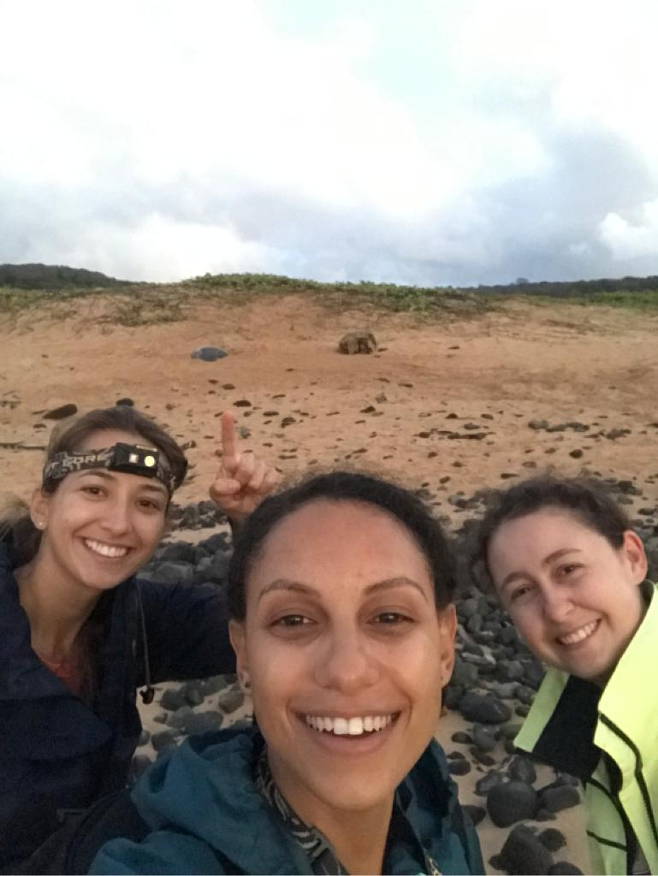

**P2. From left to right, Cintia, Dani, and Vic at the beach at sunrise while F11 finished nesting (the gray blob Cintia is pointing to).**

Dr. Fuentes, Armando, Cintia, and Daniele are our sea turtle ecology experts, meaning they know the most about this population and how sea turtles mate, nest, and generally live around the island. Dr. Lisa Komoroske leads the Molecular Ecology lab at the University of Massachusetts Amherst. Dr. Komoroske, post-doc Dr. Blair Bentley, and PhD student Estephany Herrera are the sea turtle genetics experts on the team. They will be leading the genetic analyses to help answer questions about male mating behavior on the island. We're being housed and much of the research is being conducted in partnership with Projeto TAMAR, a Brazilian non-profit organization dedicated to the conservation of sea turtles (tartarugas marinhas) in Brazil. To round out the team, Dr. Will White and PhD student Vic Quennessen are the computational modelers. We will take the data that we collect on this population and try to simulate how the population will grow (or shrink) over time.

We do a lot of field work to collect the information we need to answer questions about this population. Every night, a team of 2-5 people patrols Praia do Leão (the main nesting beach on Fernando de Noronha) to check for nesting turtles.

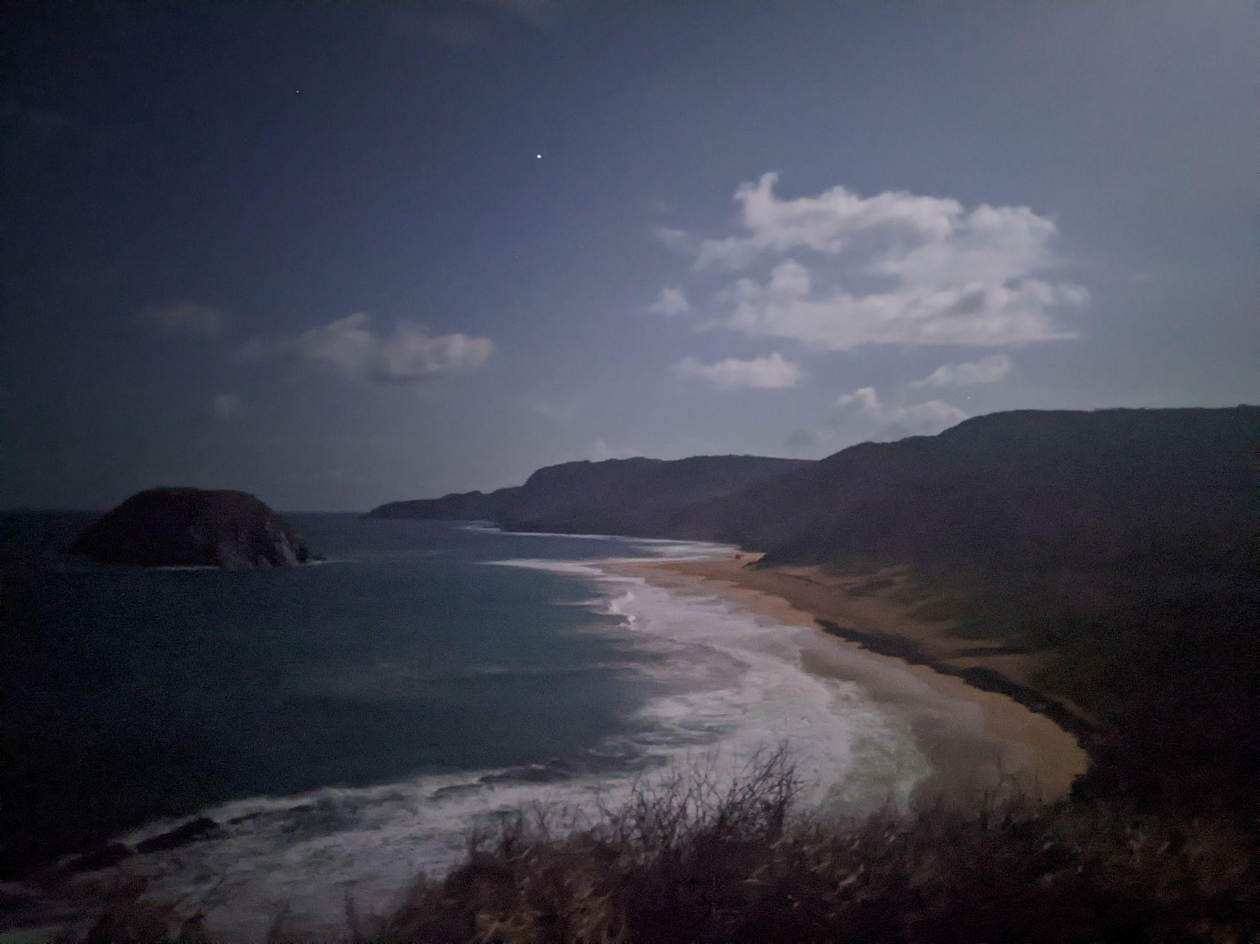

**P3. Praia do Leão at night, from the observation deck, under a full moon.**

Sometimes we see the turtle coming out of the water, but most of the time they come up between patrols, so we find their tracks. We get to the beach around 8 pm every night, and sometimes, there are already 4 turtles on the beach! If we’re lucky, they’ll all lay eggs at a different time, and we can split up into teams to watch the turtles and get ready to collect data when we can. Because first, the turtle has to find a good place to nest. Sometimes, turtles find a good spot right away – and sometimes they’ll walk around on the beach for 6 hours before giving up for the night and heading back out into the water. Sometimes they’ll also choose a bad spot – there's one part of the beach that gets flooded at every high tide. We have a couple of turtles that like to nest there, so when they’re all done, we actually have to dig up the nest, collect and count the eggs, and place them in a nest that we dig on a safe part of the beach.

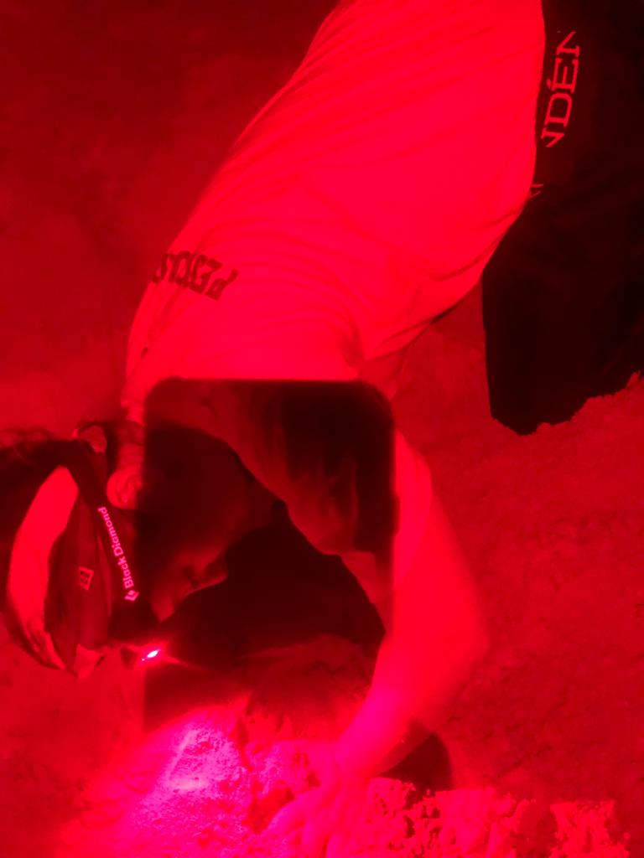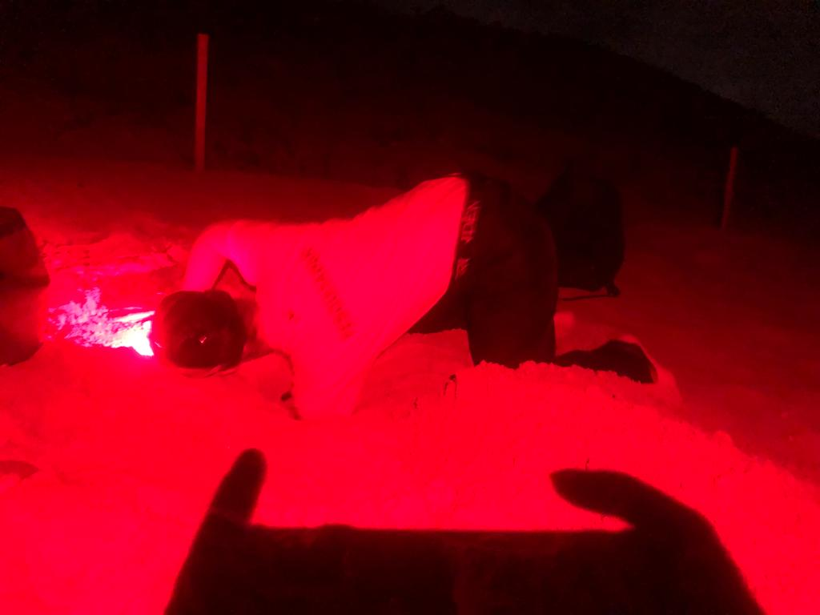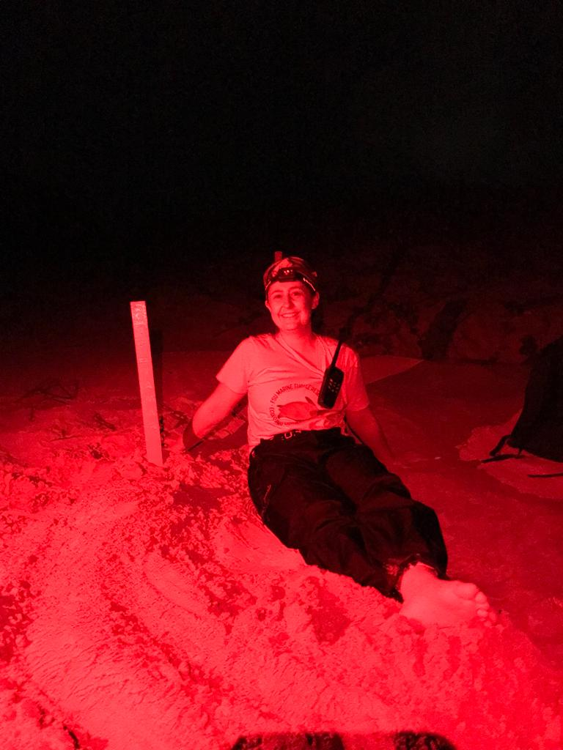

**P4. Vic digging a new nest to transfer F3’s eggs to, because F3 laid her eggs on the part of the beach that floods with every high tide.**

If the female turtle finds a good place to nest, the first step is for her to dig a body pit. This means she’ll stay in one place, and use her front flippers to smack a whole lot of sand out of the way behind her, until she’s dug a pit that she lowers herself down into. This can take anywhere from five minutes (if she cheats and uses another turtle’s old body pit) to half an hour (if she digs a big one from scratch, or if she’s tired and goes slowly). 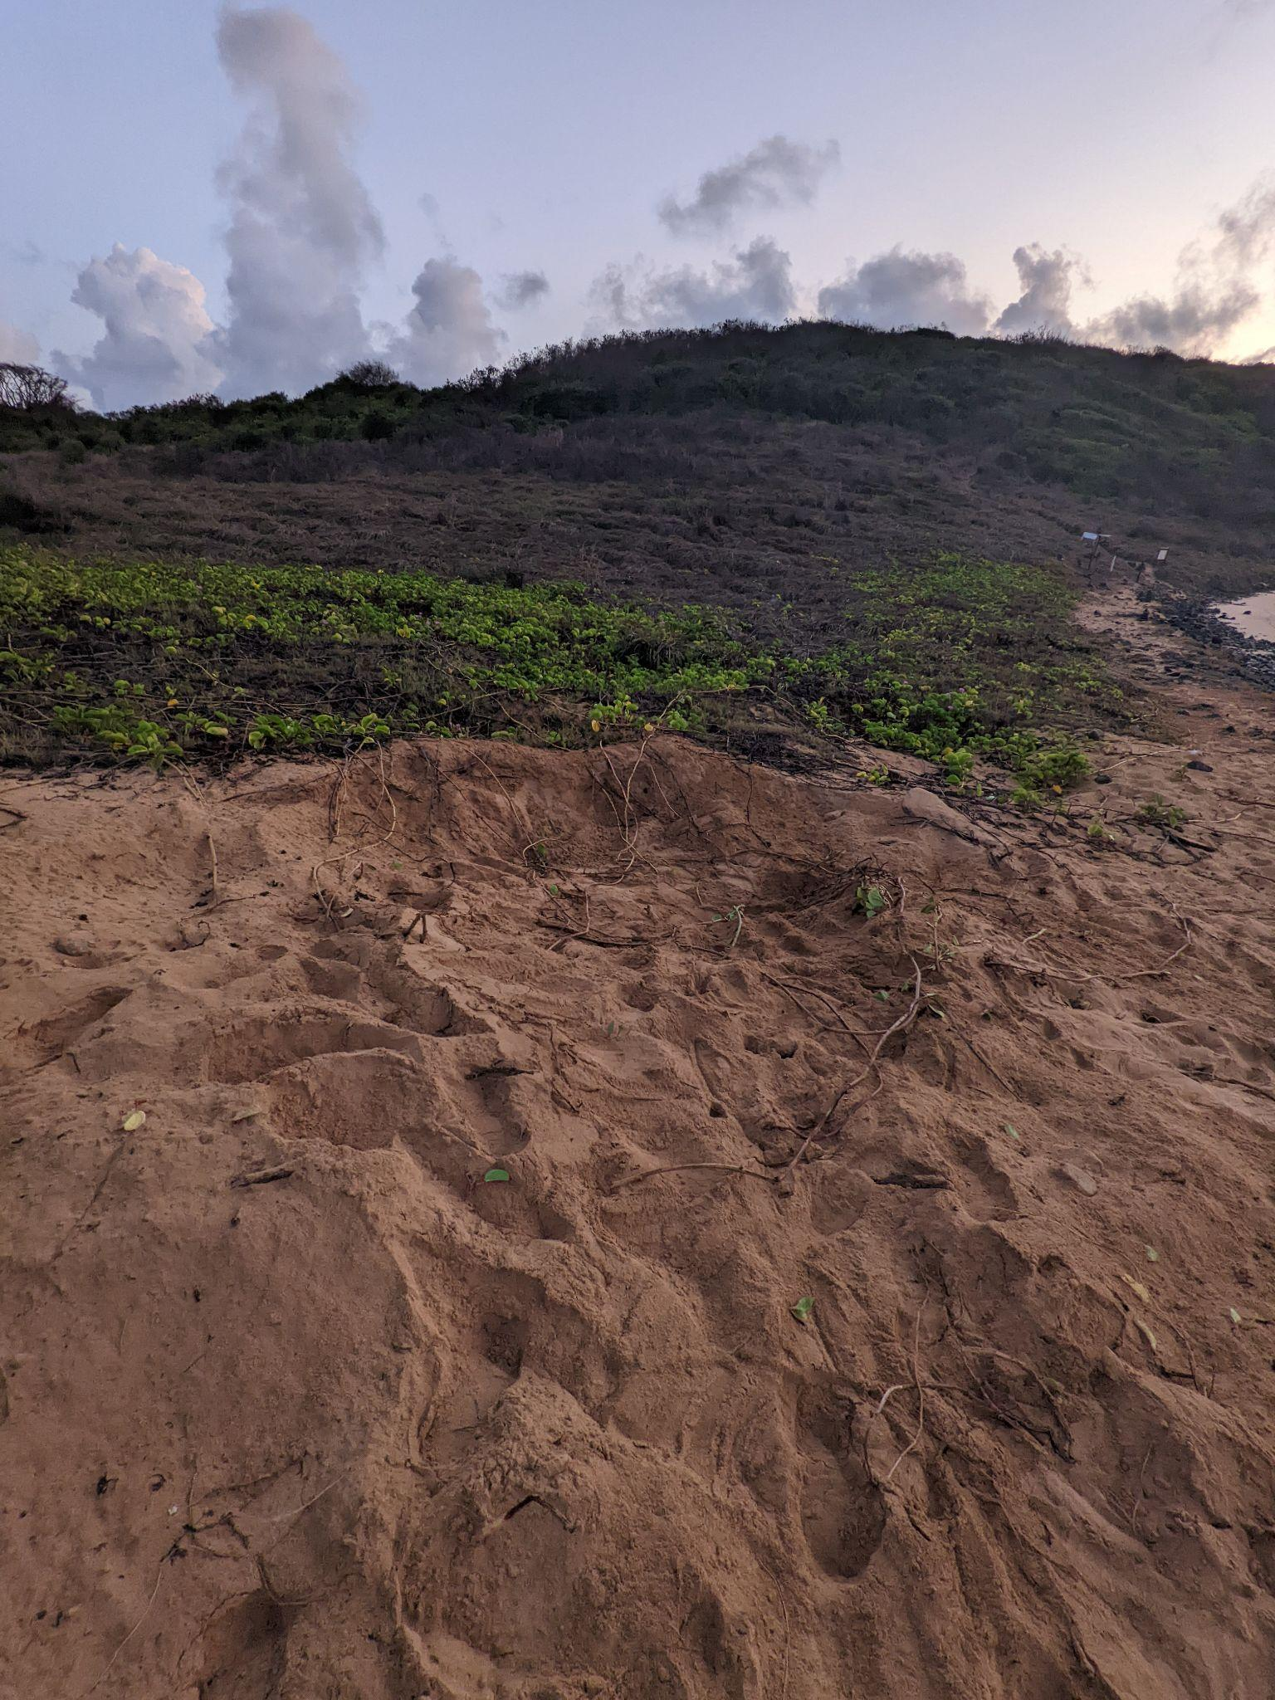

**P5. Body pit dug by F8, before she decided to return to the ocean without laying (probably because there were too many plants in this spot, making it hard to dig a deep enough egg chamber to lay eggs).**

If she doesn’t find too many rocks, she then starts to use her back flippers to dig a smaller, deeper egg chamber within the body pit. This part usually takes about 20 minutes. It’s easy to tell when she starts this part, because she will start wiggling slowly left and right to get leverage for her flippers to get the sand out of the way. When she stops wiggling, that’s when we crawl up, quietly and from behind, to not scare her. When we’re right behind her, we take our headlamps (always set to red light, so it’s less visible from far away and we’re less likely to scare turtles away), and we check to see if she’s laying eggs. If we see eggs in the chamber, we can turn on our lights and start working! Female turtles enter a kind of hypnotized state as they’re laying eggs, so she won’t react to us collecting data.

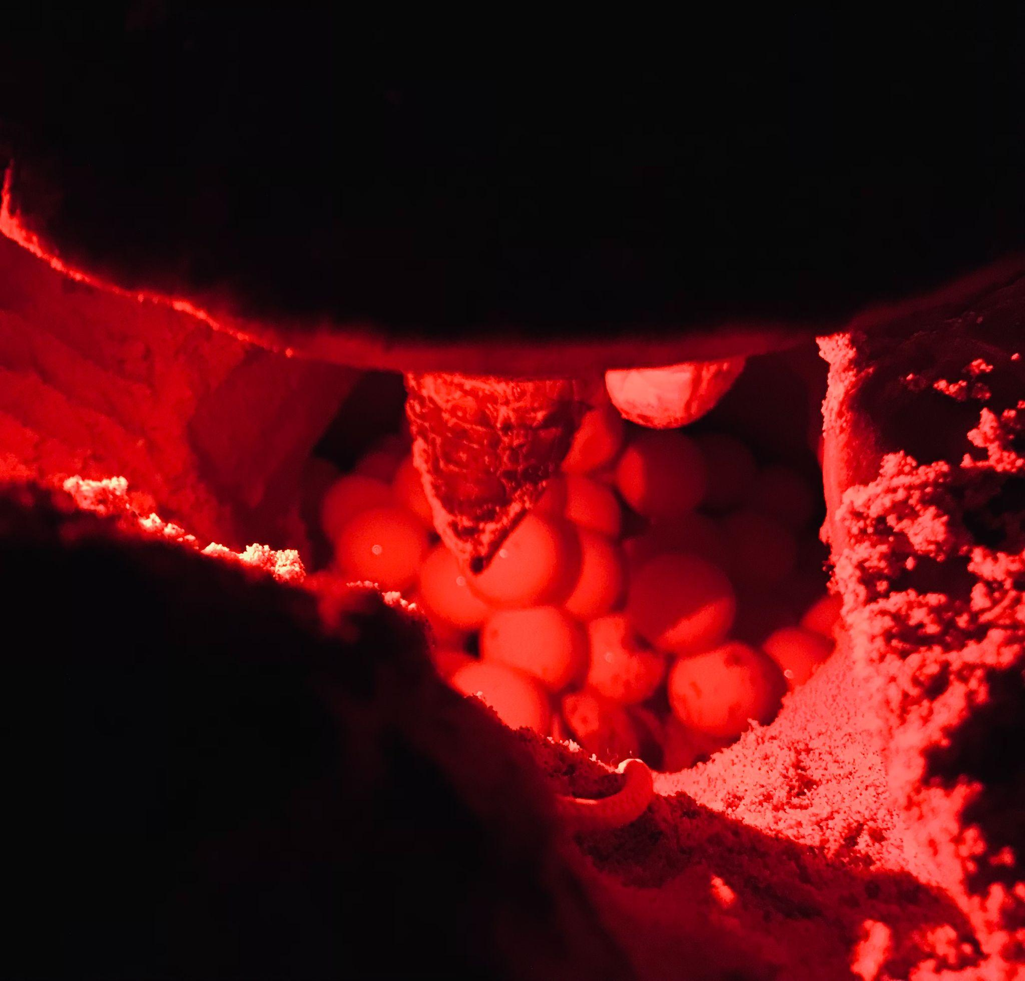

**P6. Eggs in the chamber as F11 is laying them. We use a red light because it doesn’t travel as far as white light, so other turtles on the beach aren’t disturbed by the light as much and don’t get scared away.**

When we get a new turtle, the first thing we do is check if she has tags – we want to be able to keep track of who’s laying nests and where and when, so tags are essential. More often than not, it’s a returning female who already has tags. Every once in a while, though, it’s a new turtle who hasn’t laid eggs here (or maybe anywhere!) before, so we add tags to her front flippers (or her back flippers, if she’s very big and the tag doesn’t fit on the front flippers).

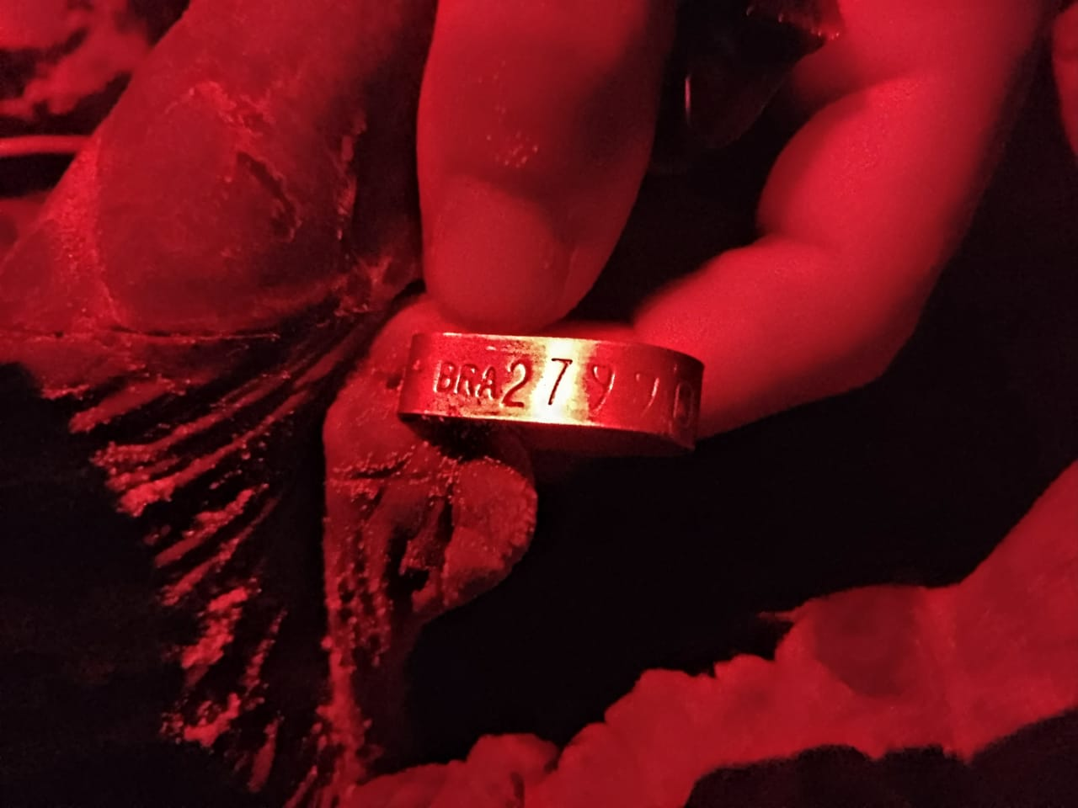

**P7. Picture of one of F2’s tags. This one reads BRA 27990. We use the tags to keep track of turtles throughout and between nesting seasons. This helps us estimate how many laying females there are in the whole population, since they don’t nest every year.**

Then, we use a measuring tape to measure the length and width of the carapace (shell). We also take a very small skin sample from her neck, which we’ll use later for our genetics analysis. We use nail polish to paint a number on the shell to make her easier to identify from a distance and in the water. We mark the nest with a stake, and depending on our sampling design, we attach a rock or a temperature logger to the stake (to make it easier to find the nest later). We use a GPS to mark the exact location of the nest (latitude and longitude). Finally, we take lots of photos – of the tags, of her head from different angles, of any distinguishing features or injuries, and of her shell paint and the stake, for identification and record-keeping.

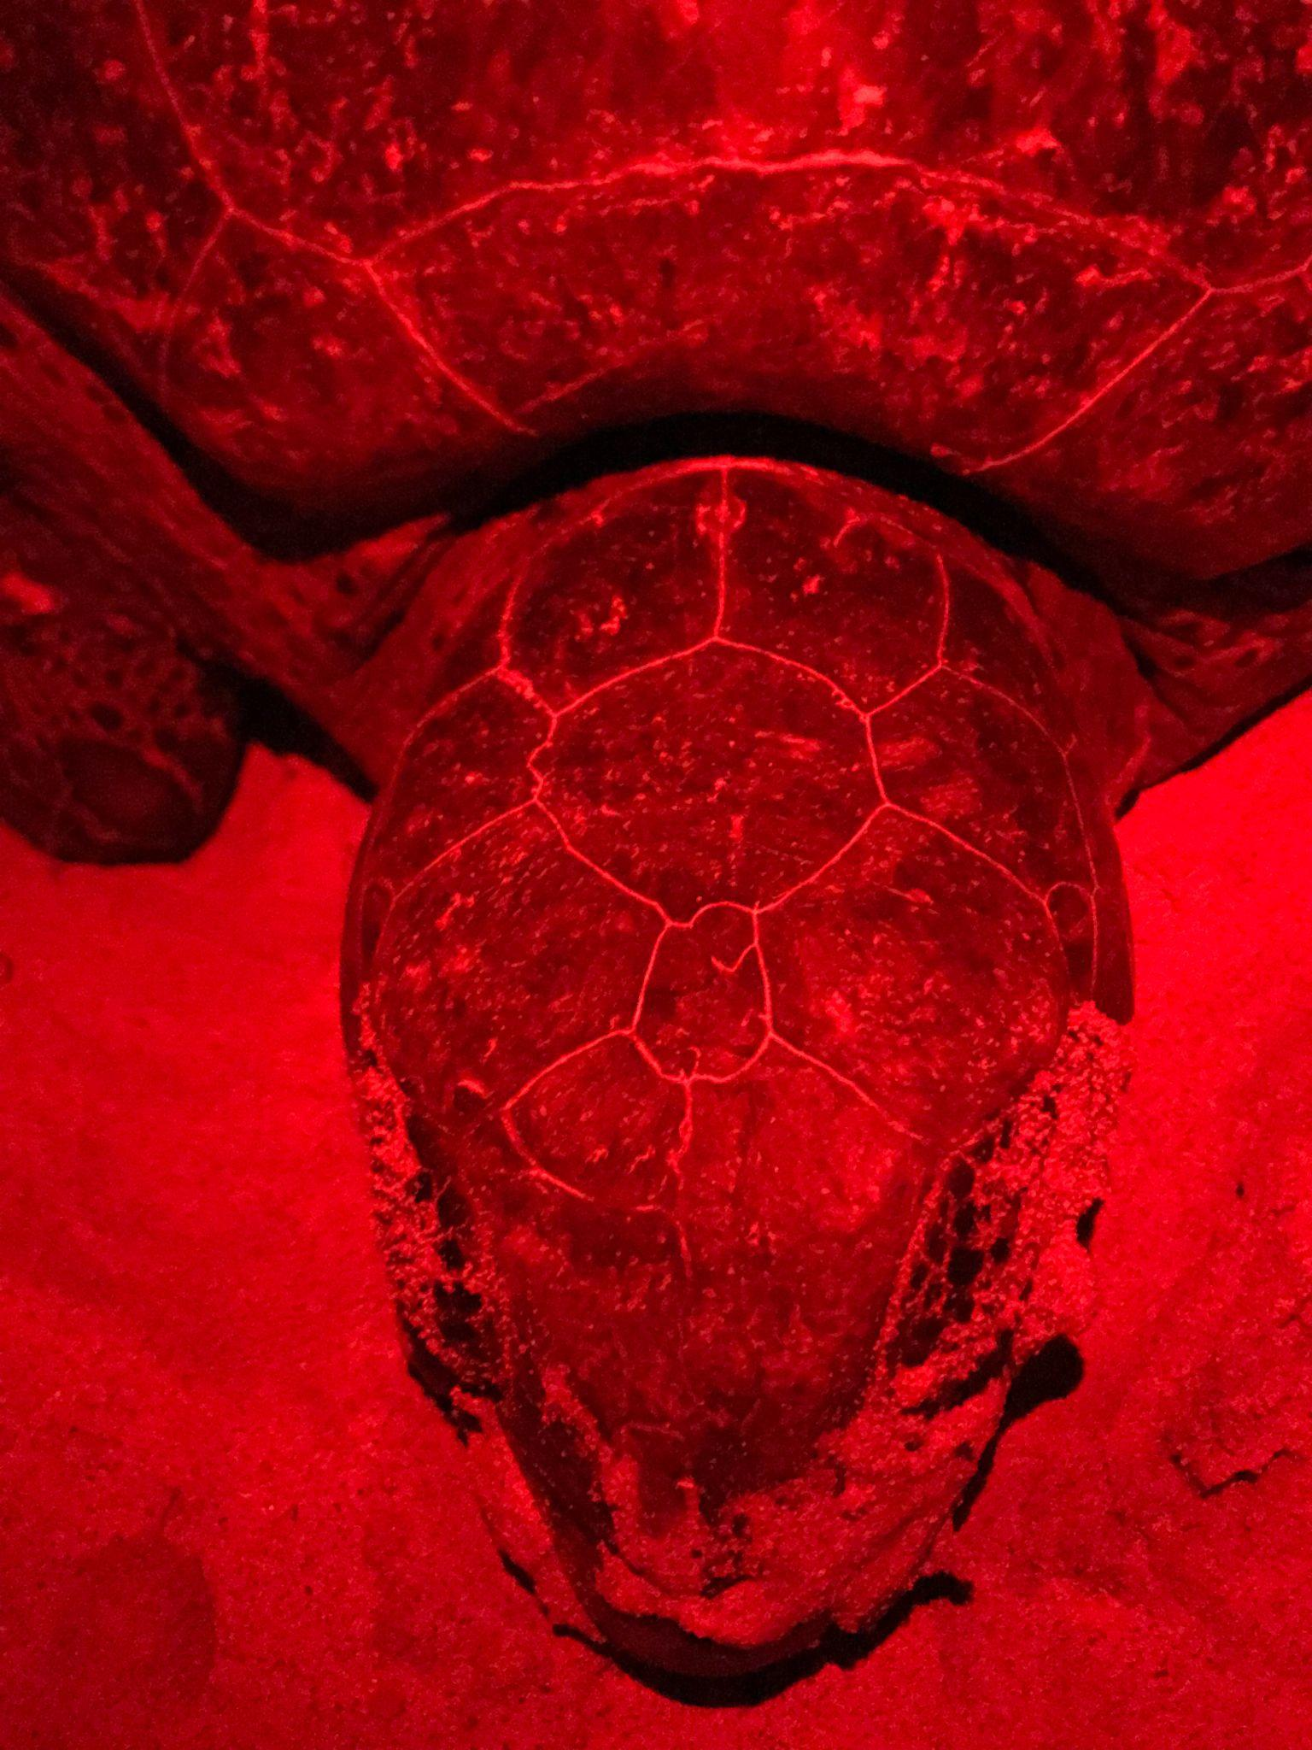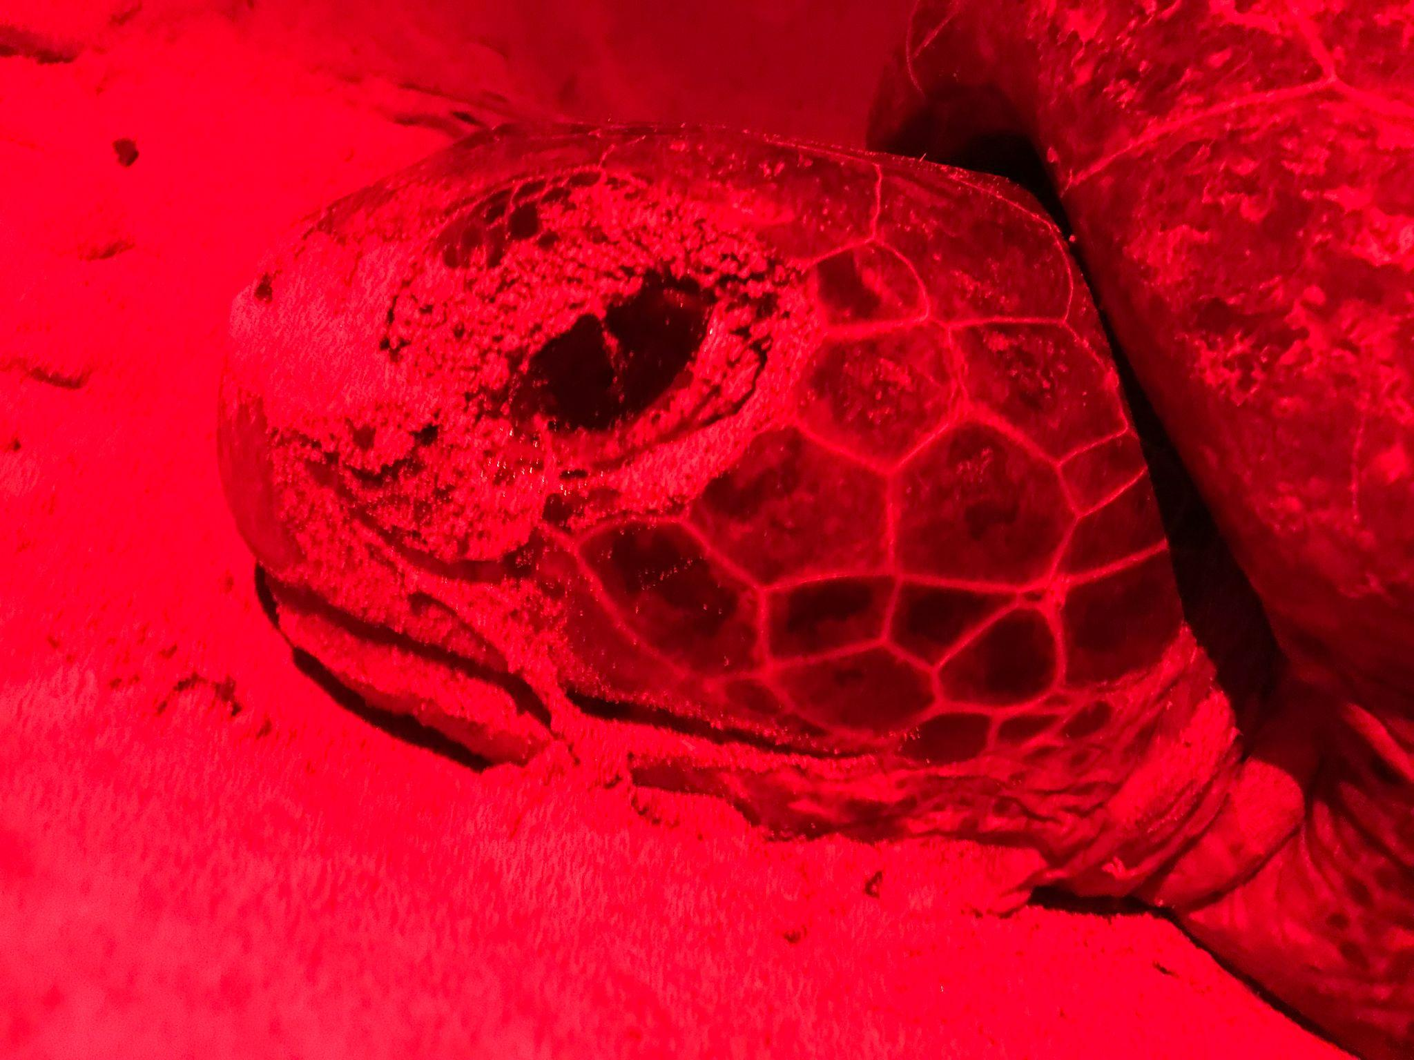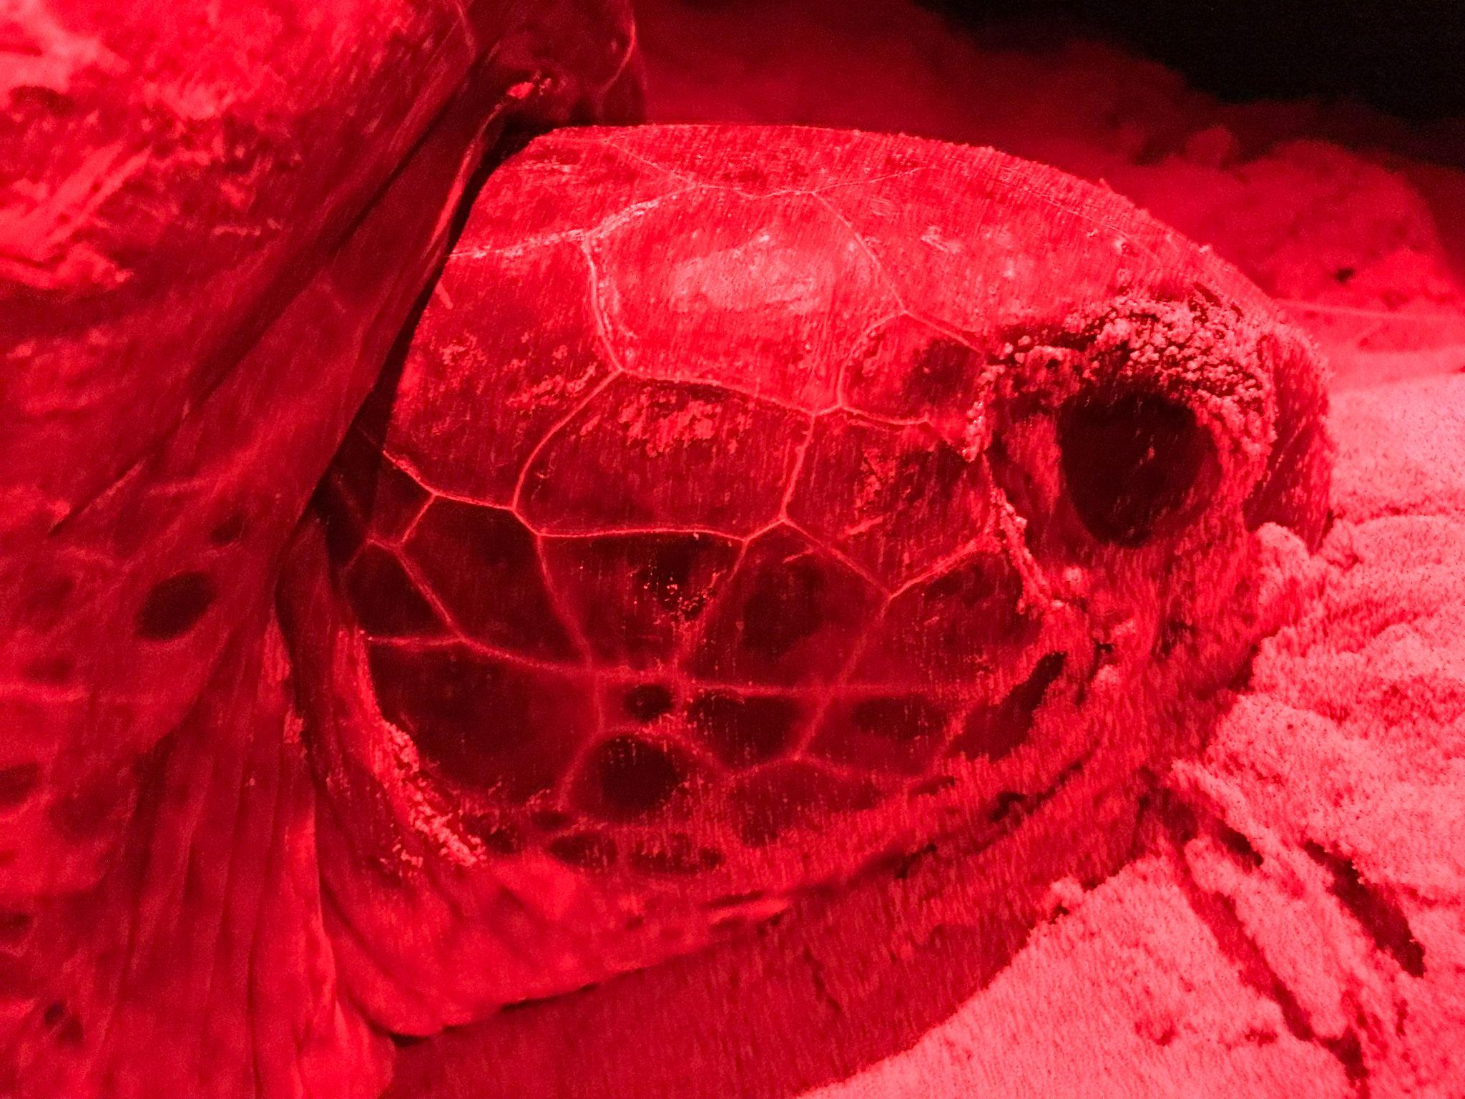

**P8. ID photos of F4 after her first nest (from left to right): the top of the head, the left side of the head, and the right side of the head.**

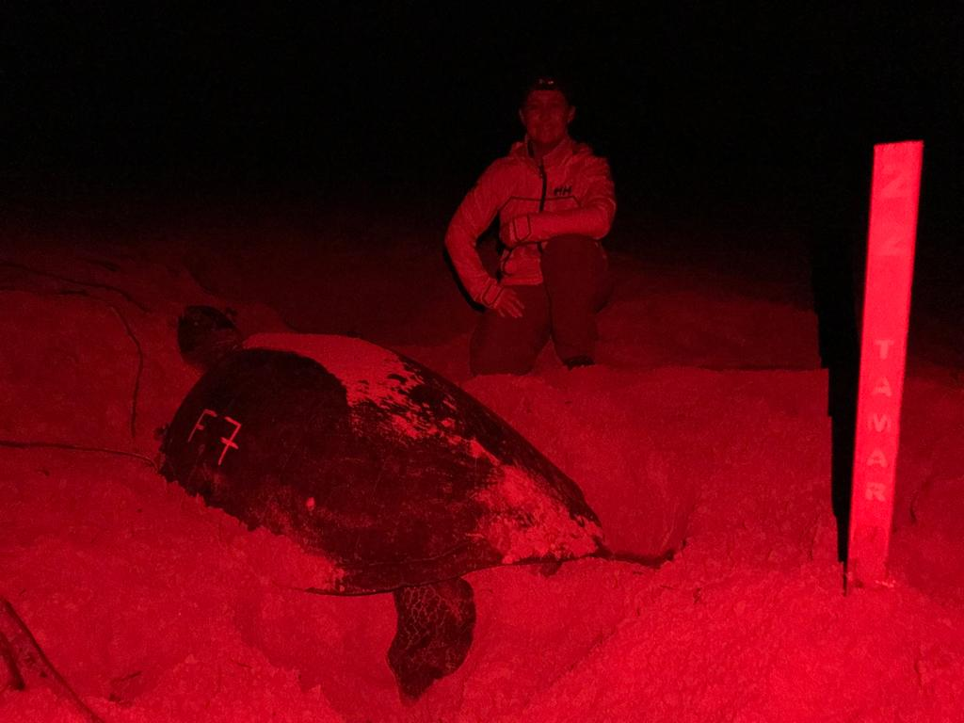

**P9. Vic posing with F7 with her shell paint and stake number (nest number 22).**

After we’re done, we help her fill in the chamber, so that she doesn’t knock over the stake or disturb the rope with the temperature logger attached. Once she’s filled in the chamber, she’ll start using her powerful front flippers to throw more sand over the nest. That way, when she’s done, the nest full of precious eggs will be buried deep and safe from predators, and there will be a decoy body pit with nothing for them to eat.

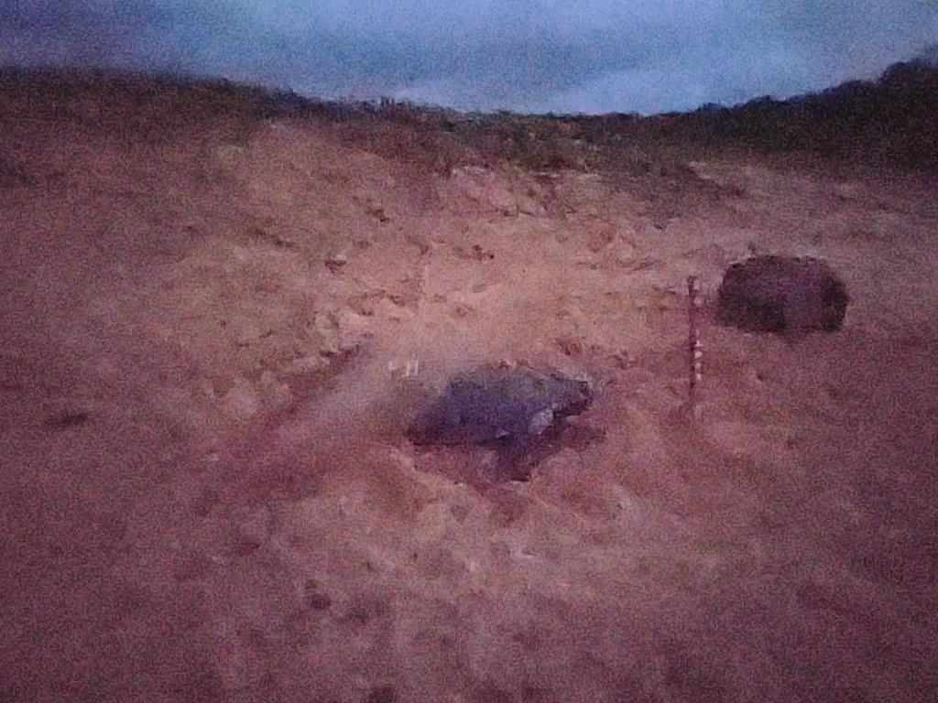

**P10. F11 camouflaging her nest at sunrise after nesting. The big blurry part of the picture is the sand she’s flinging.**

Once nests have been in the ground for long enough (around 45 days), we have to use that string attached to the stake to find the nest. Then, we add a mesh cage around where the hatchlings would come out.

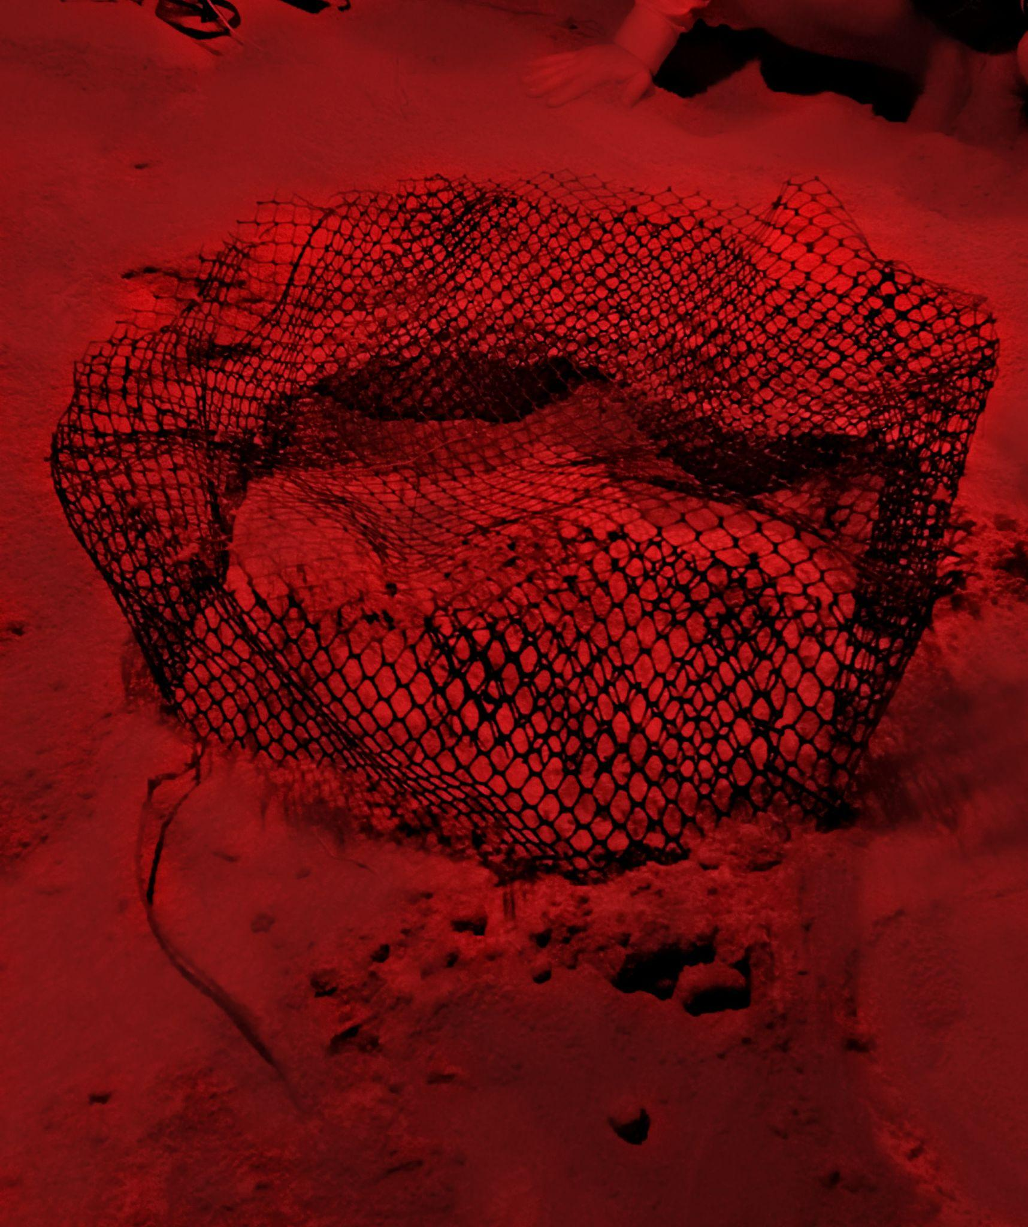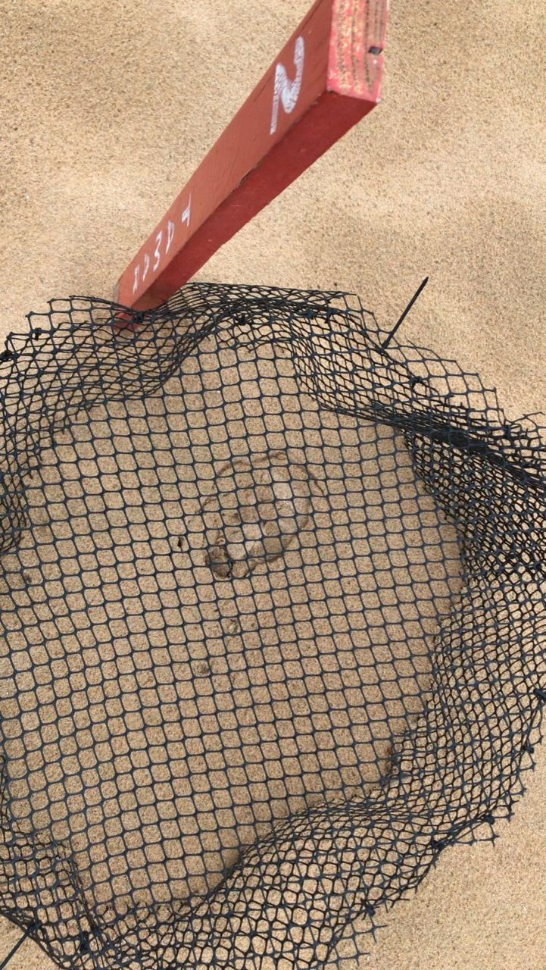

**P11. Pictures of cages over nest 2 (from left to right) the night we caged it, and during the day when it was sunk before the first hatchlings emerged.**

This helps us to capture the hatchlings, and also helps to protect them from predators on the beach – at Fernando de Noronha, their predators include frigate birds, taigu lizards, big rats, and crabs.

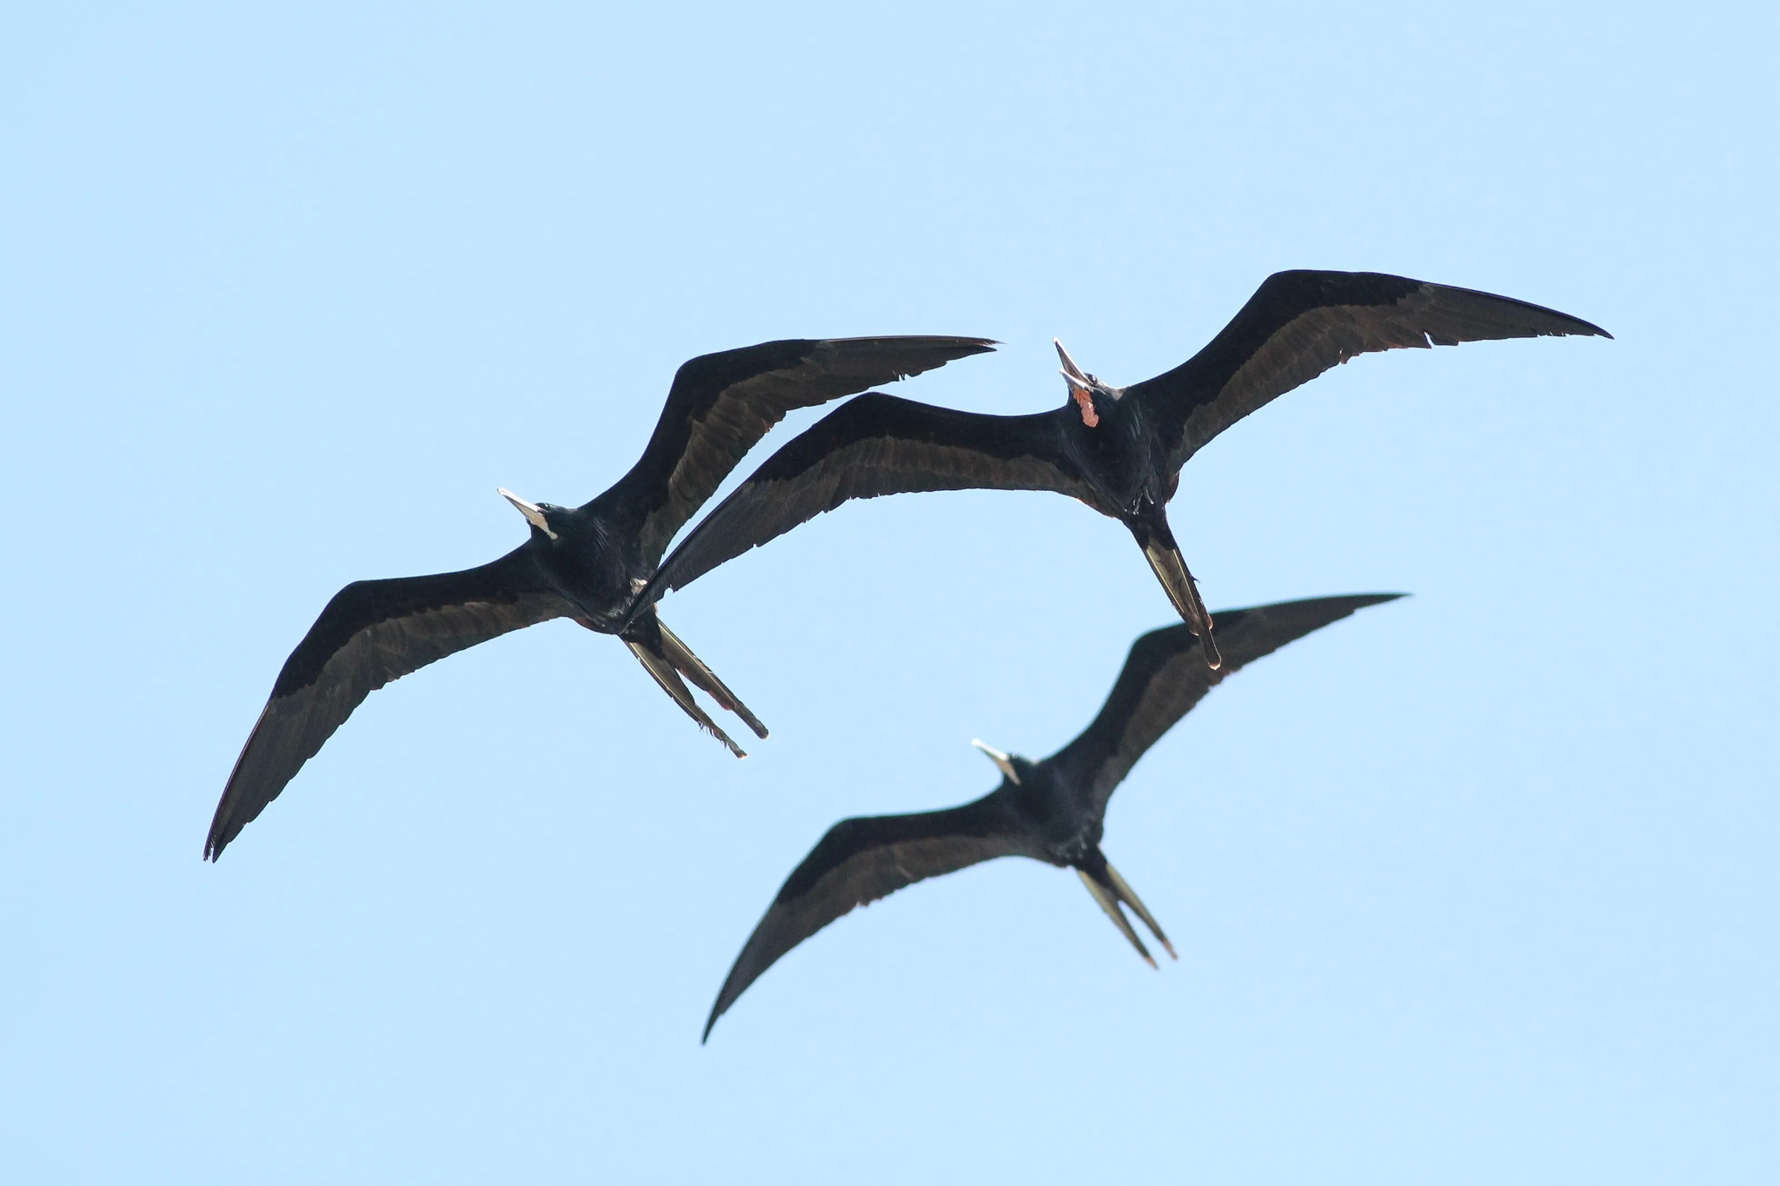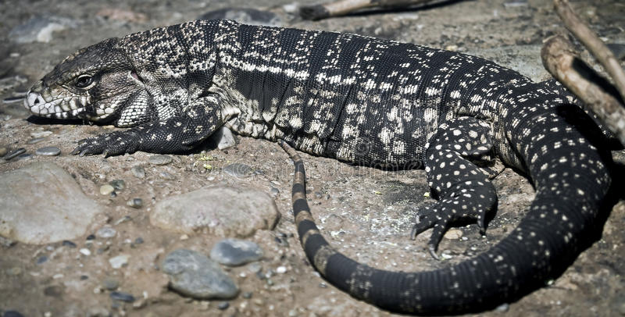

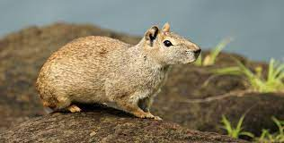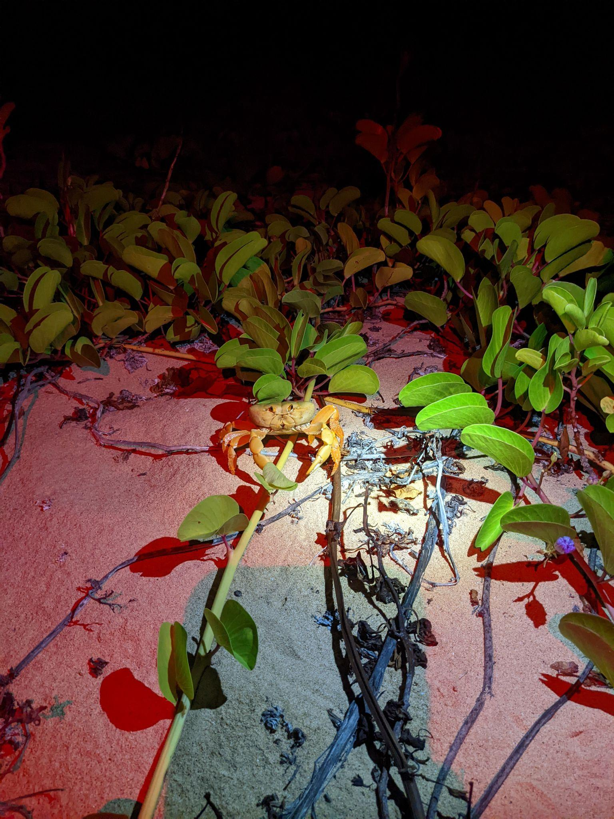

**P12. From left to right (top, then bottom), a frigate bird, a teju, a rat, and a crab from Fernando de Noronha.**

After 45 days in the ground, we check the nests on every patrol at night, and also every morning at 6:30, right after the sun comes up, to protect them from the heat. Once it gets hot enough, they won’t come out – they pay attention to the temperature, and only come out when it’s cold, since there are fewer predators that eat them at night, when it’s colder. Unfortunately, the temperature also goes down when it rains, so we have to run to the beach to check on the nests every time it rains during the day too.

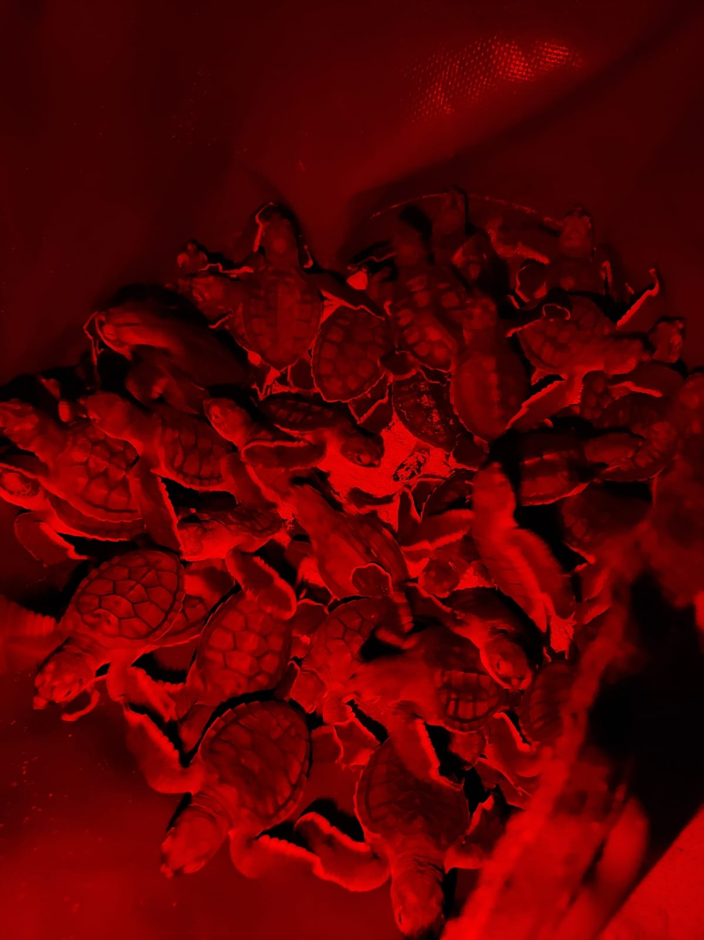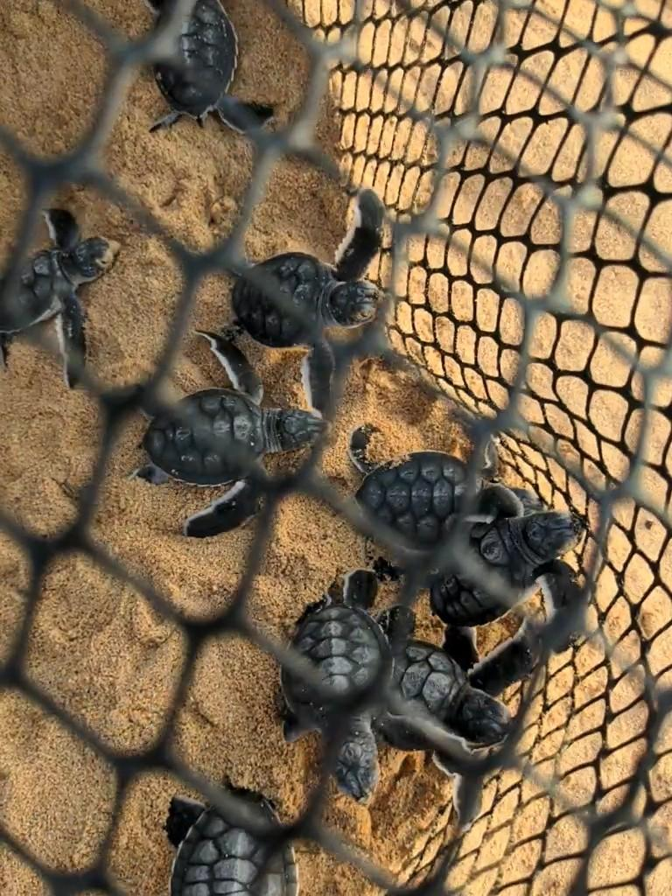

**P13. Hatchlings that emerged at night from Nest 3 (left) and in the morning from Nest 5 (right).**

When we get hatchlings, we transport them to the beach house in a blue bag with humid (not wet) sand so they don’t get dehydrated. There, we set up all the equipment we need to measure them; we weigh them, and use a caliper to measure the length, width, and depth of their bodies.

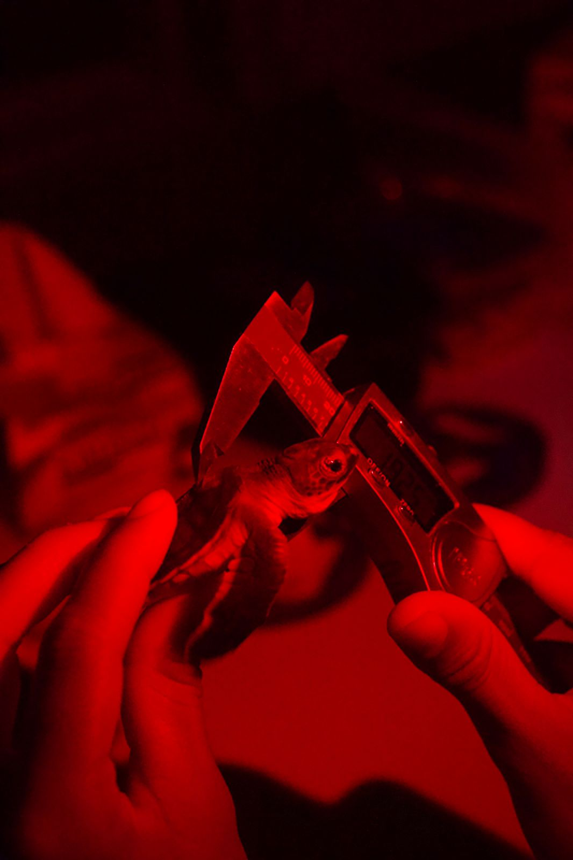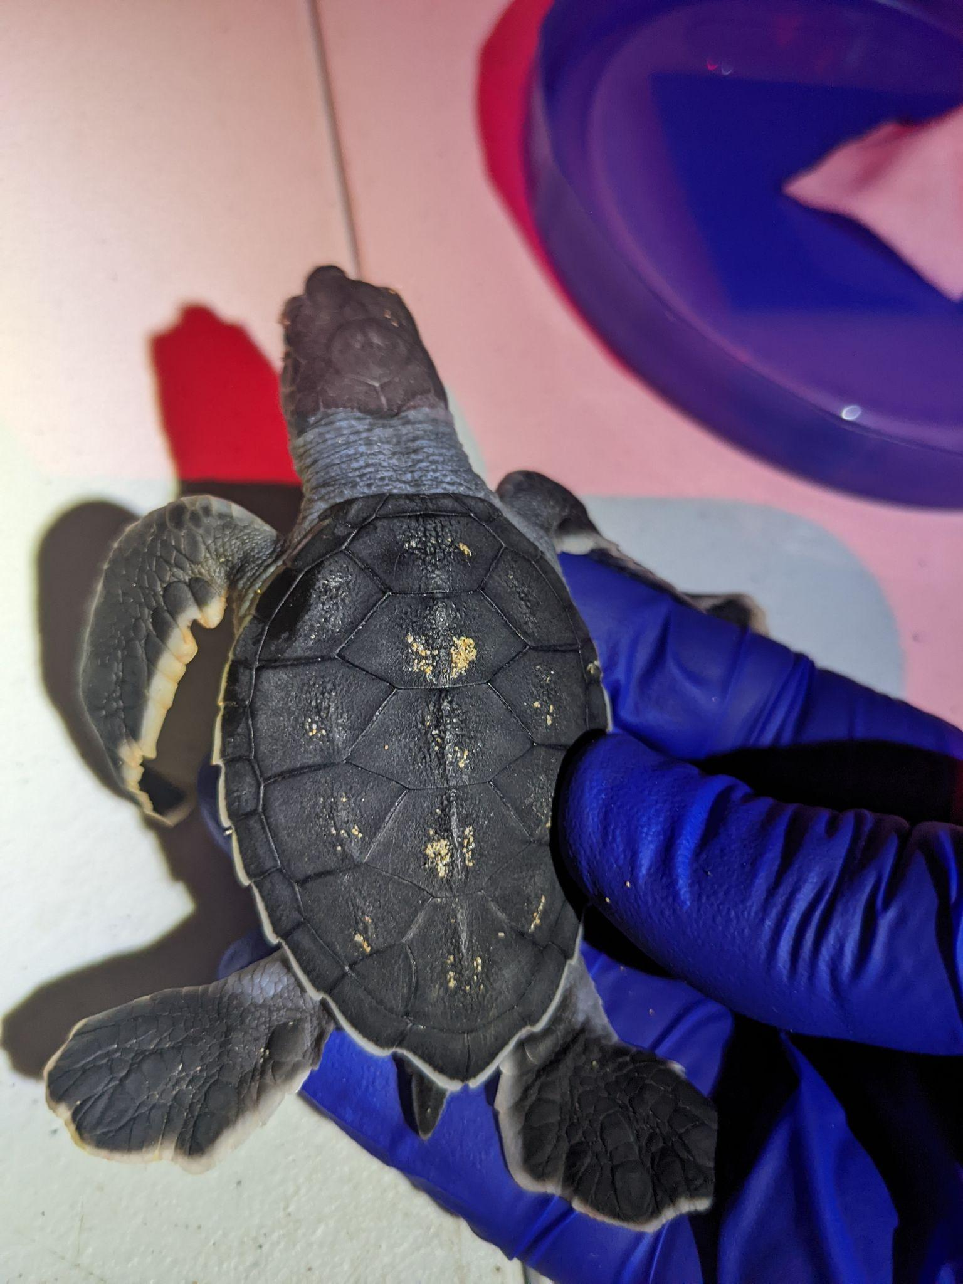

**P14. Left: measuring a hatchling’s depth with digital calipers. Right: a hatchling with an extra left costal scute from Nest 2 (the scute that is triangle-shaped on the bottom left corner of the carapace (shell)).**

We also take pictures of any hatchlings with irregular scutes to potentially identify them when they come back to nest in 25-40 years.

Finally, we take a tiny little skin sample from them, and place them in a separate bag with humid sand. Once more than 20 hatchlings have come out of a nest (which can be all at once, or sometimes happens in small waves over a few days), we excavate the nest, take out any hatchlings that are left, and count the eggs that did and didn’t hatch. When we’re all done collecting data, we get to do the best part – release the hatchlings. First, if it’s a little light out, we make sure there are no frigate birds in the air. If it’s dark, we check the water for little lemon sharks that like to hang out where the surf breaks. If the coast is clear, we release the hatchlings, and watch them make their way out to the big blue ocean.

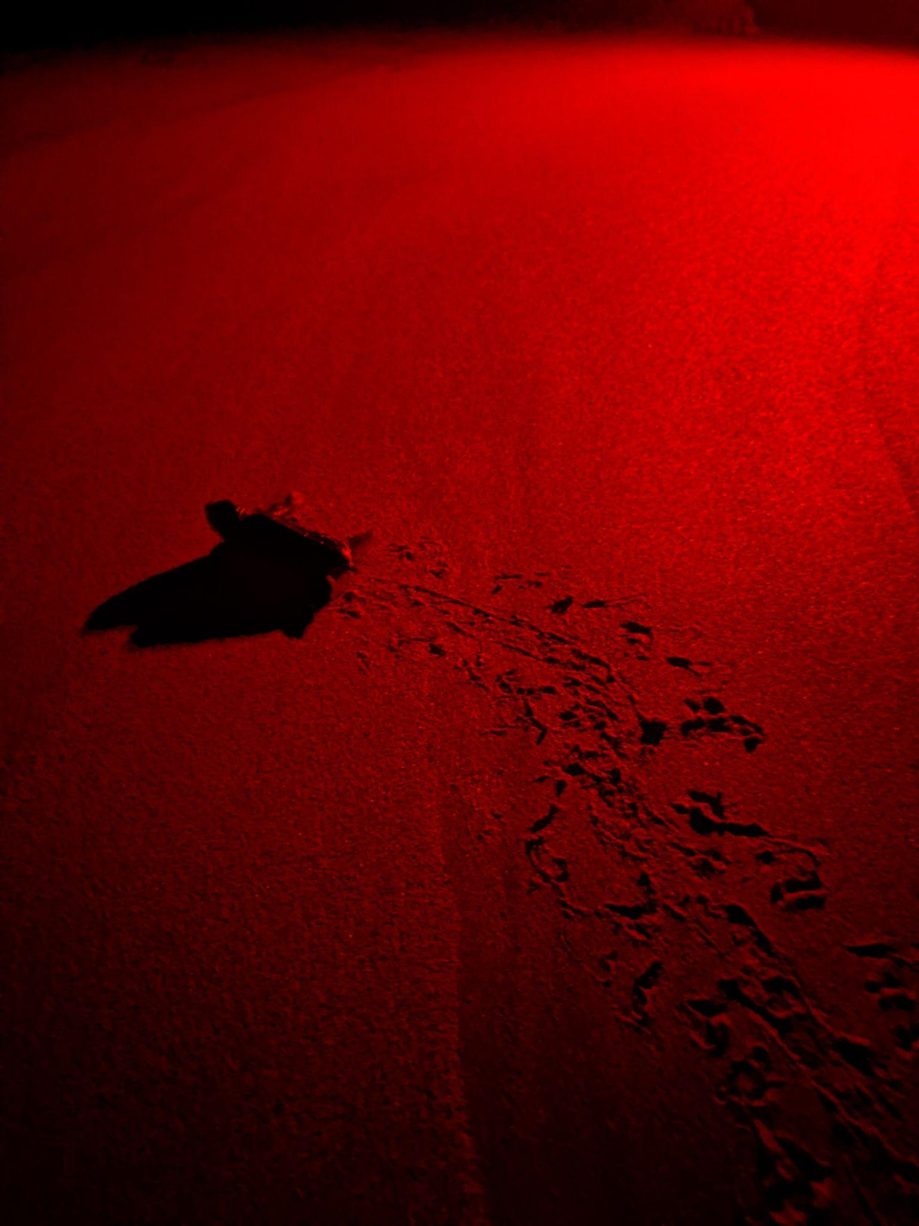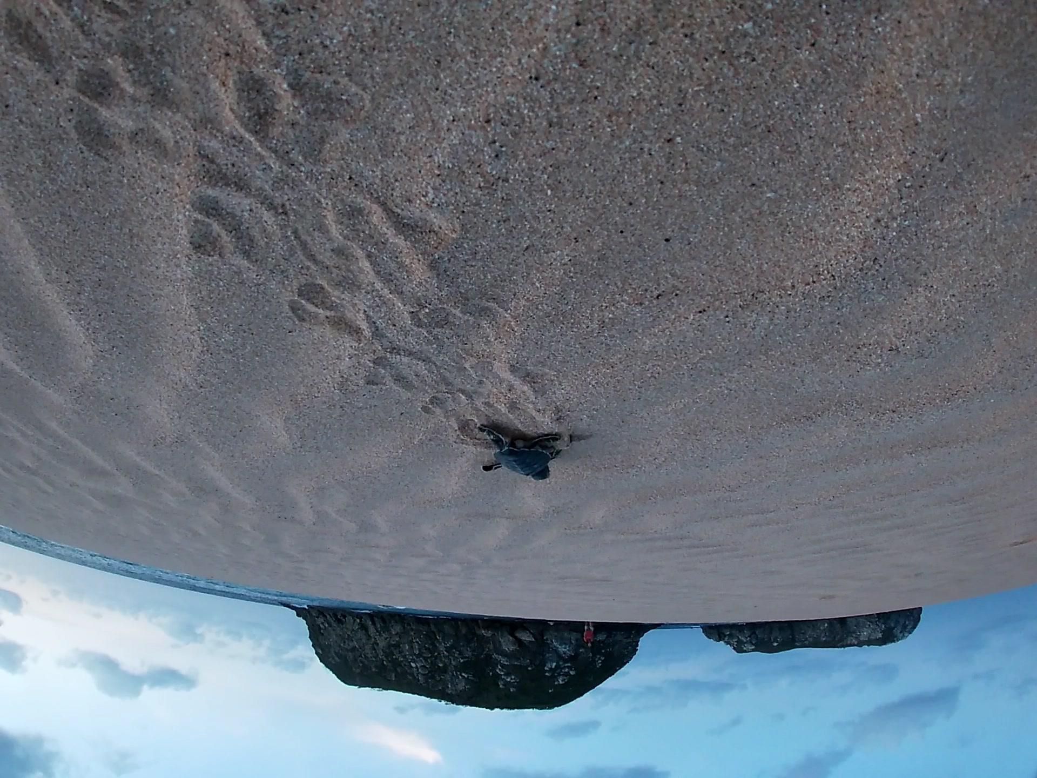

**P15. On the left, one of the first hatchlings from Nest 5 making her way to the ocean at night, after we’ve checked for sharks. On the right, another hatchling from Nest 5 that came out in the morning making her way out to the ocean at sunset. When the hatchlings emerge during the day, we take them back to the house during the day, and come back to the beach to release them when the sun goes down, so that there are no frigate birds around to catch them and eat them.**

Besides collecting data on land, we also collect data from the water! On boat days, we pay for a boat and crew to help us capture males so that we can collect data: tags, measurements, photos for ID, and a skin sample, just like for females.

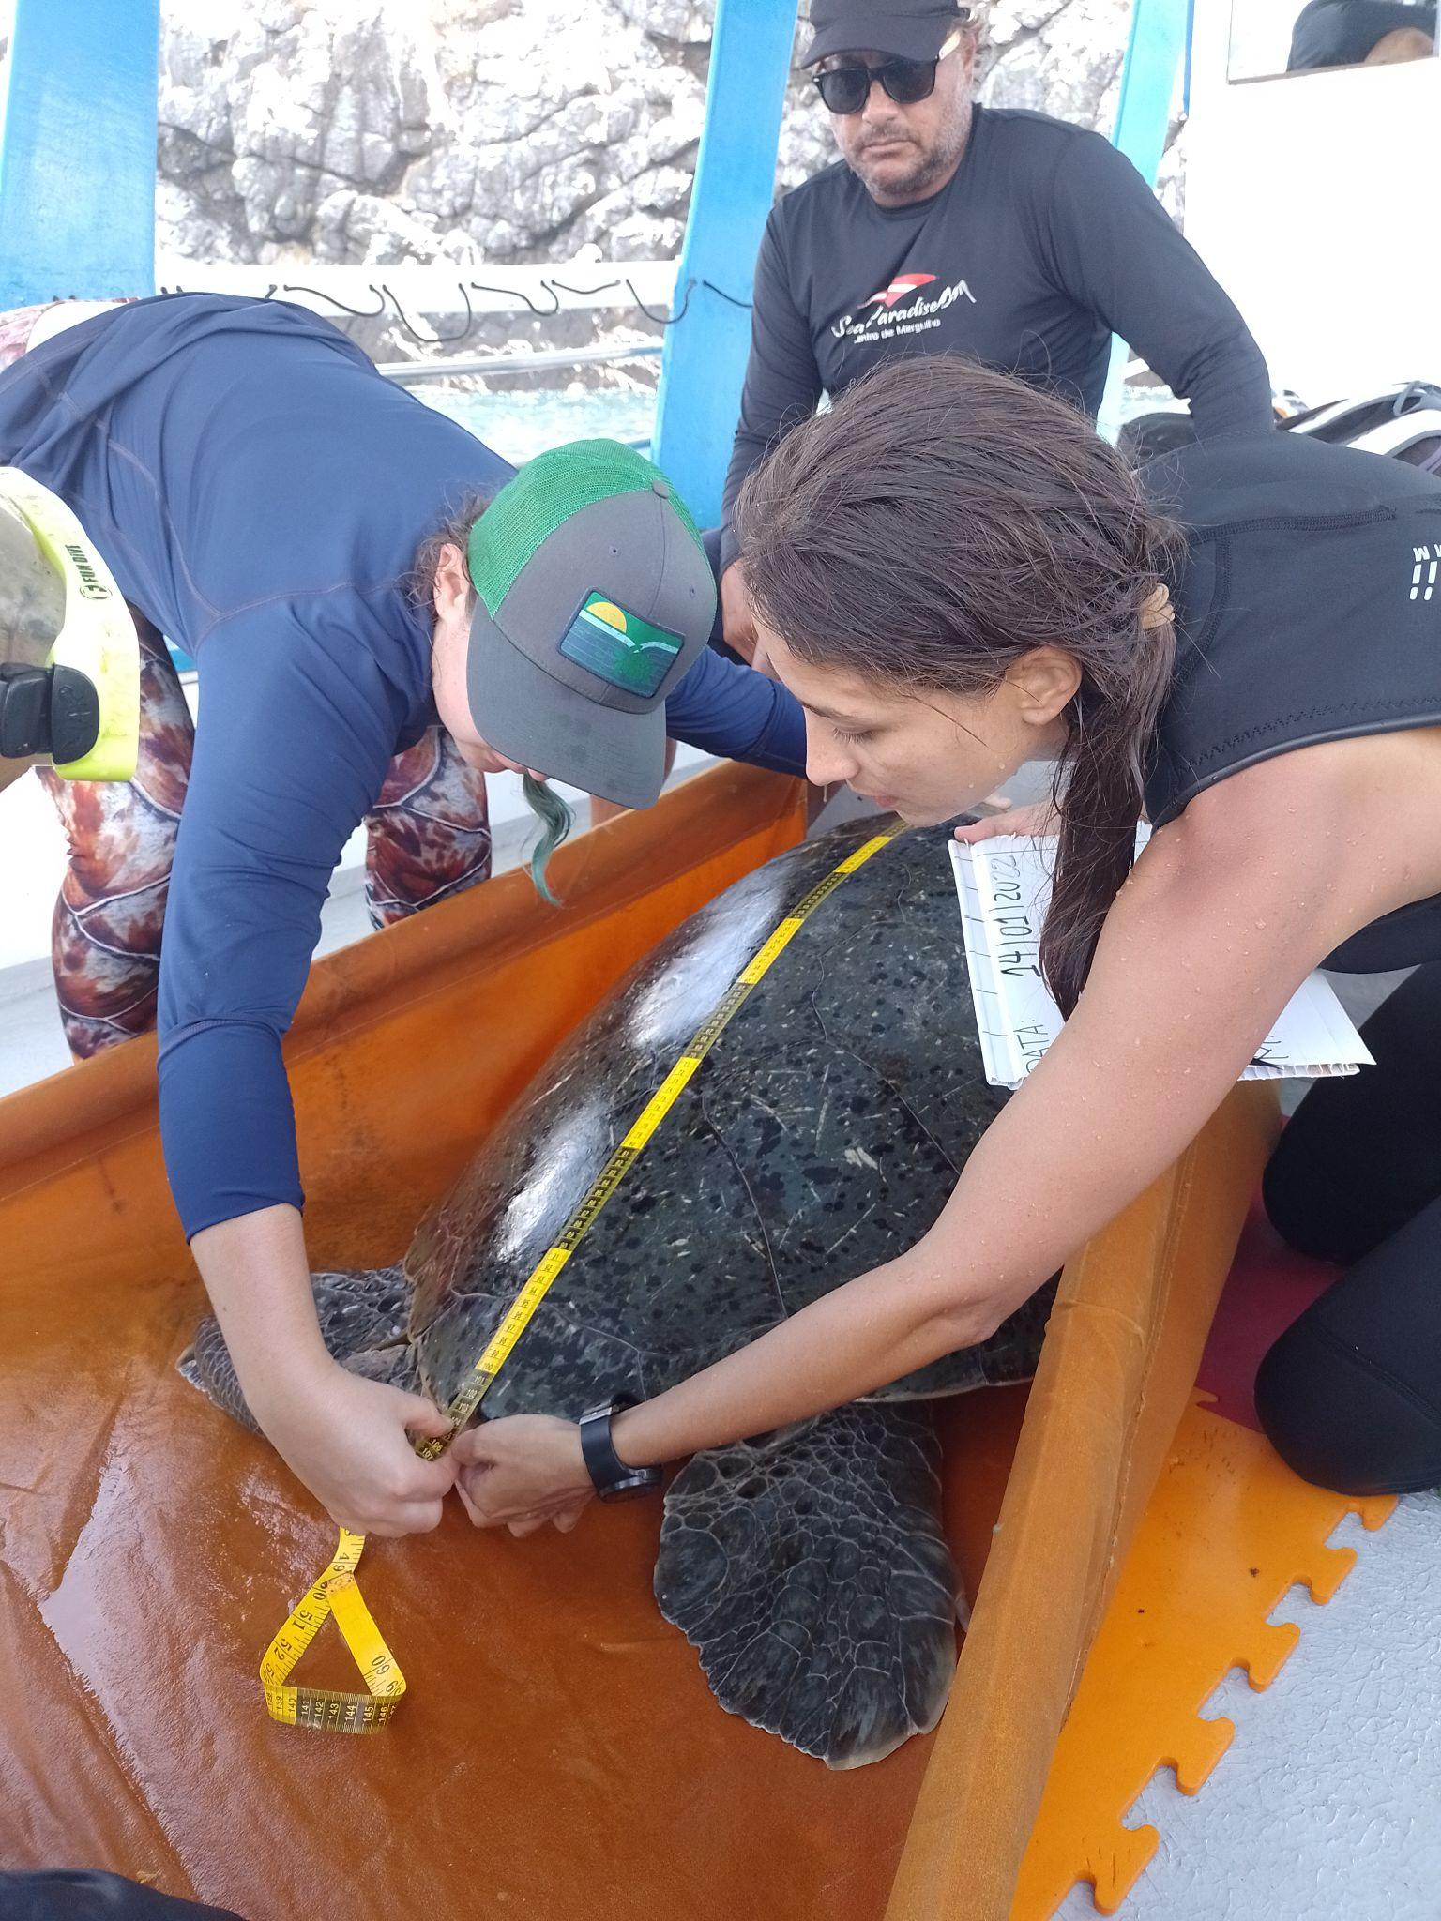

**P16. Cintia teaches Vic how to measure a sea turtle’s carapace (shell) on M5 on the boat.**

We also attach a satellite tag!

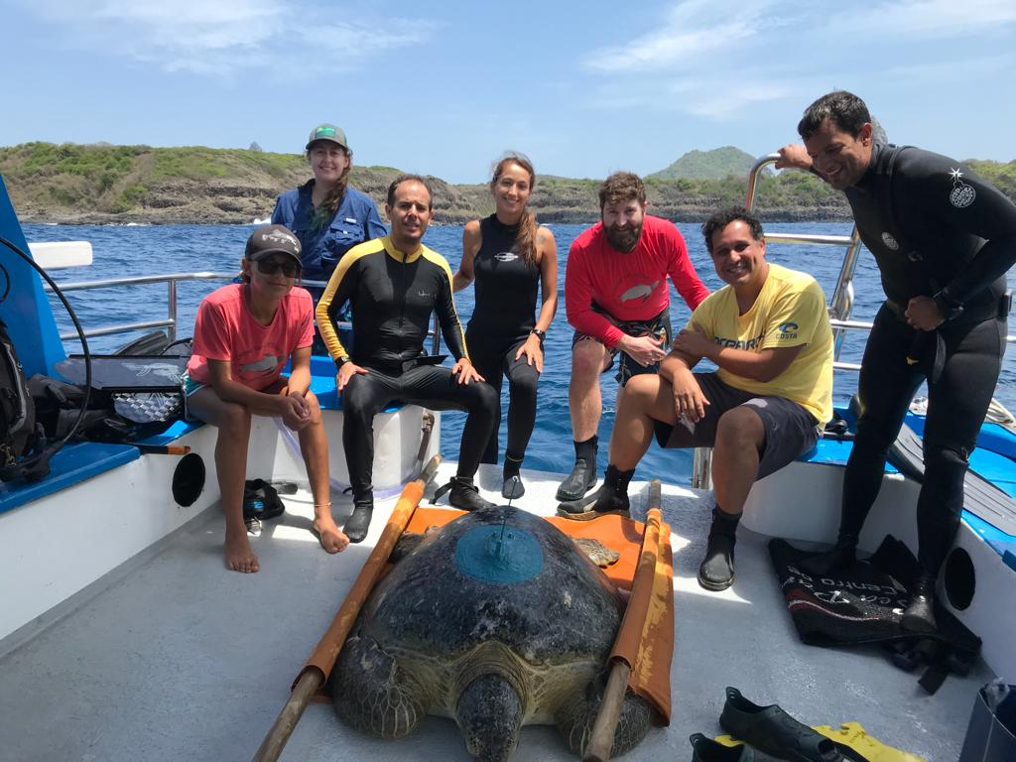

**P17. A group photo with M8 while waiting for the attached satellite tag (the big blue spot on the top of his carapace, or shell) to dry. From left to right, Dani, Vic, Armando, Cintia, Blair, Erick (a visiting scientist who works extensively with spatial data from sea turtles), and Marcelo, a private diver who helps with sea turtle captures on boat days.**

This will give us information about where he goes and how far he travels, until the tag falls off. With any luck, it’ll stay on for a long time (up to several years) to give us lots of good data! It records his position whenever he comes up to the surface of the ocean to breathe, and also records the maximum depth that he dives down to. With this amazing map (thanks Armando!), you can follow the satellite tracking of 19 different male green turtles that were tagged in Fernando de Noronha in real time. Visit this link to check it out: <https://my.wildlifecomputers.com/data/map/?id=5fd6003831af5916904322b6>

Finally, three days a week, we do surveys in the water with snorkels. We jump into the water at Caracas, and swim over to Leão beach, checking under rocks for turtles that are hanging out. Sometimes we also see them copulating, resting on the bottom, or just swimming around in the water. Using a GoPro, we try to get close enough to ID them if they’re marked. If it’s an unmarked male, we try to capture it, and take a skin sample in the water to help our genetics analyses. Even if we don’t capture anyone, we can get information about which males and females are in the area. The fact that we’ve never seen a marked female mating with a male in the water (from 10 years of observations from TAMAR folks, like Armando) also gives us valuable information – that the females here probably don’t start nesting until after they’ve finished mating!

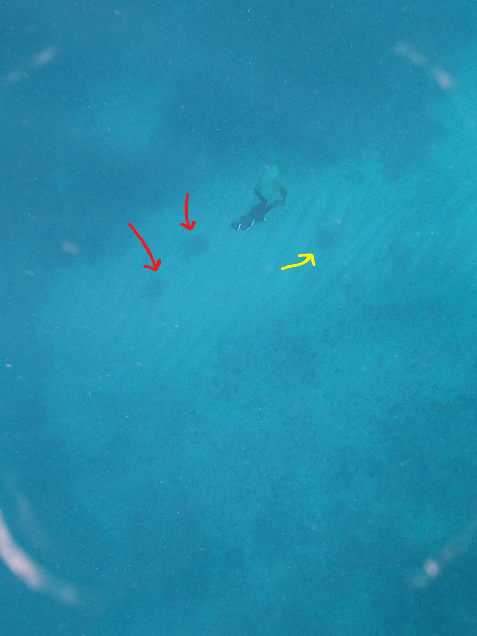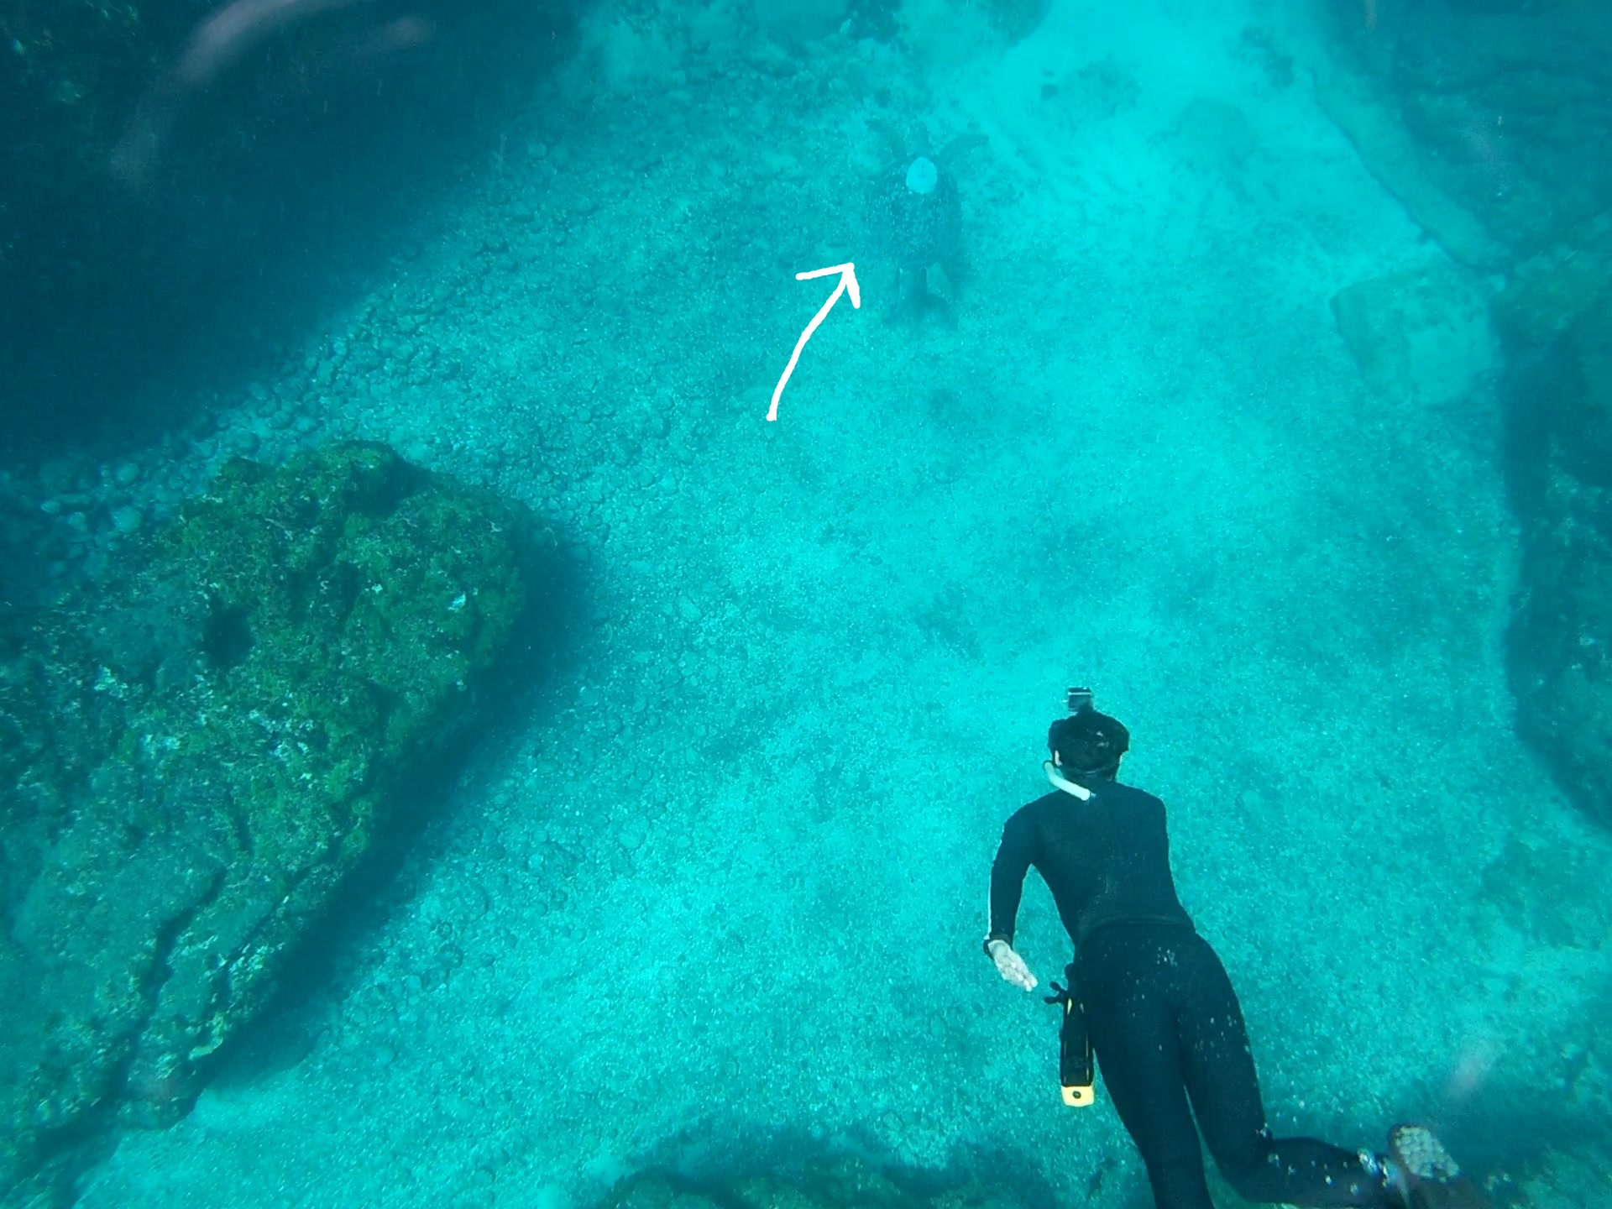

**P18. Left: Armando diving down on a transect to identify 2 females resting on the ground (red arrows). To his right is also a hawksbill juvenile (yellow arrow). Left: Armando diving down to try to identify a male that has a PTT satellite tag on it (white arrow).**

Using the skin samples that we’ve collected from females, males, and hatchlings, we try to match the dads to the nests, and find out if there is more than one dad for any nest. This will help us understand if males are mating with more than one female or not. Our genetics team is also working on ways to tell the sex of the hatchlings (if they’re male or female) using the skin sample we take already. This information would be hugely helpful for better understanding how the temperature of the beach affects the amount of female and male hatchlings that are born every year.

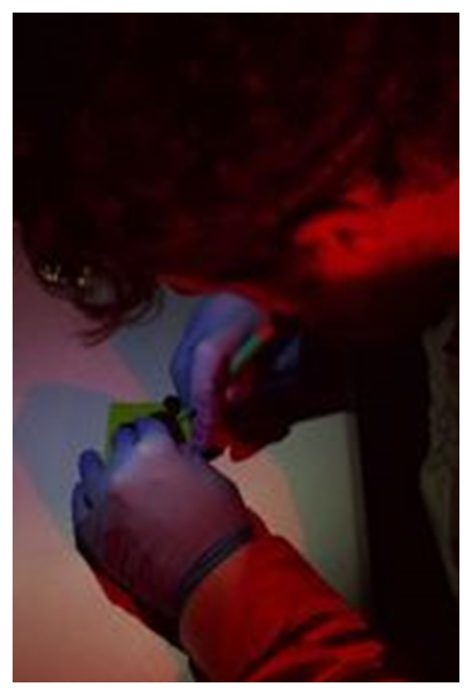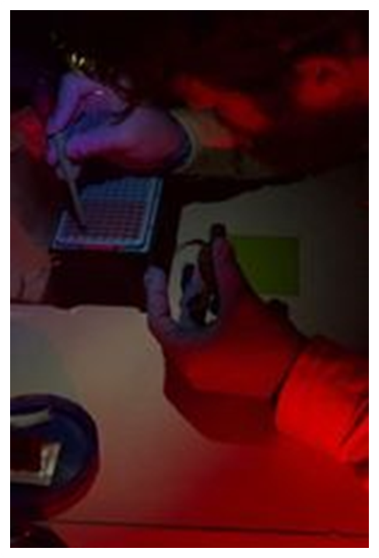

**P19. Dr. Blair Bentley taking a very small sample from a hatchling from Nest 3 (left) and placing the sample into a 96-well plate (right). We will then ship all these samples from Brazil to the UMass Amherst lab in Massachusetts for analyses so that we can figure out who this hatchling’s father is.**

Finally, we take all of the information we’ve collected with all this work (the number of nests each female lays, the number of eggs in each nest, the number of females males can mate with) and we can plug it into a computational model. The model is just a lot of code, written in R, that takes all of these relationships we’re discovering, and uses them to simulate how the population will grow or shrink over time with different climate change scenarios. The model can also include adaptations – ways that animals change their bodies or their behaviors to survive better – to see if they help the population survive for longer.

Hopefully, when all this work is completed, we’ll have a better idea of if sea turtles will survive on their own with rising nesting beach temperatures. And if not, we’ll hopefully be able to find conservation strategies that help the most to keep them alive. Stay tuned!

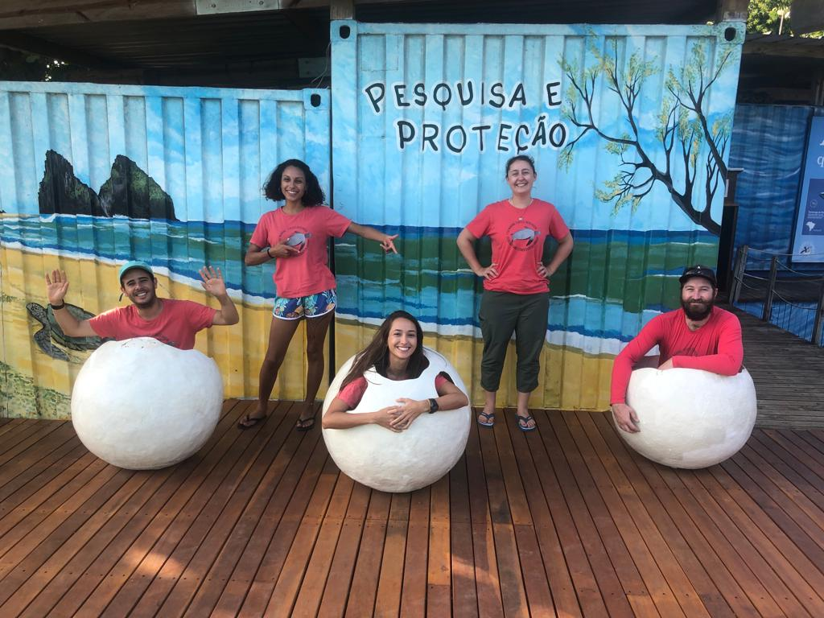

**P20. A team photo at TAMAR’s visitor center. From left to right: Armando (Florida State University), Dani (FSU), Cintia (FSU), Vic (Oregon State University), and Blair (University of Massachusetts Amherst). The mural behind us says “Pesquisa e proteção”, which is Portuguese for “Research and Protection”.**